Module 1
Input/output, variables and basic arithmetic
(QUES 1)code:
#include <stdio.h>
int main(){
int num;
char a[16];

scanf("%d", &num);
scanf("%s", &a);

printf("%d\n", num * 2);
printf("%s\n", &a);

return(0);
}
Screenshot:
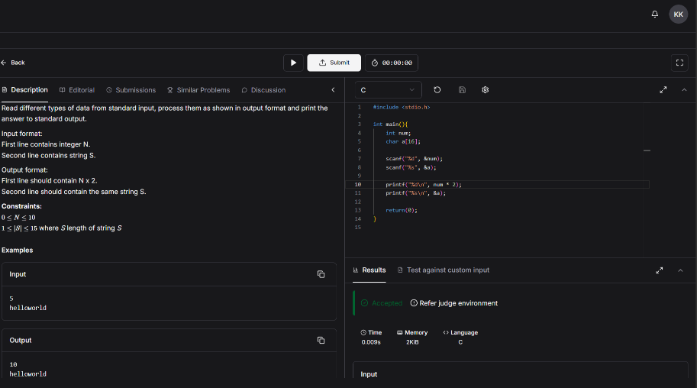
url: https://www.hackerearth.com/practice/basic-programming/input-output/basics-of-input-output/practice-problems/algorithm/io-exercise/

(QUES 2) code:
#include <stdio.h>
int main() {
int a,b;
scanf("%d %d",&a,&b);
int sum;
sum = a+b;
printf("%d",sum);
return 0;
}
Screenshot: 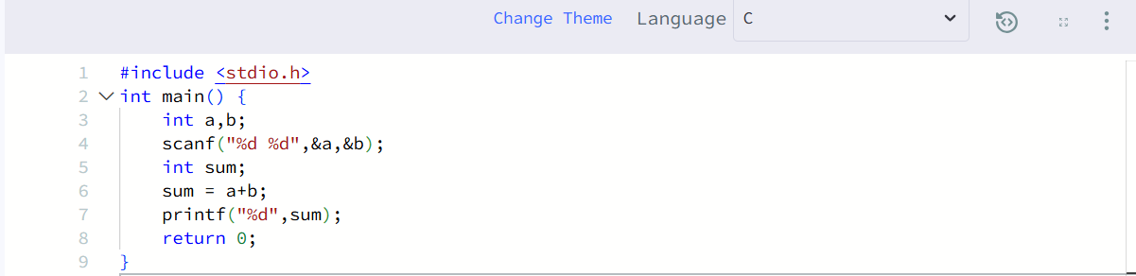
url: https://www.hackerrank.com/challenges/solve-me-first/problem

(QUES 3) Code:
int sum(int num1, int num2) {
return num1 + num2;
}
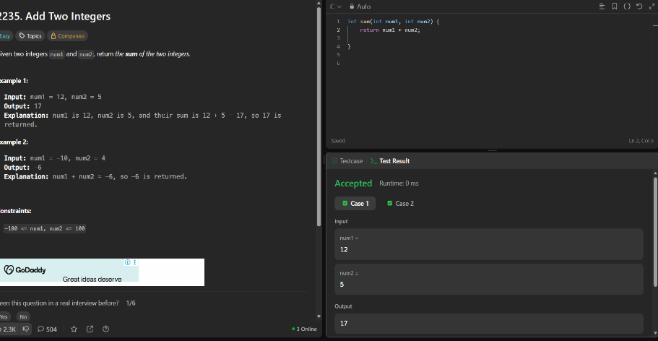
url: https://leetcode.com/problems/add-two-integers/

(QUES 4) CODE:
int findDelayedArrivalTime(int arrivalTime, int delayedTime) {
return (arrivalTime + delayedTime) % 24;
}
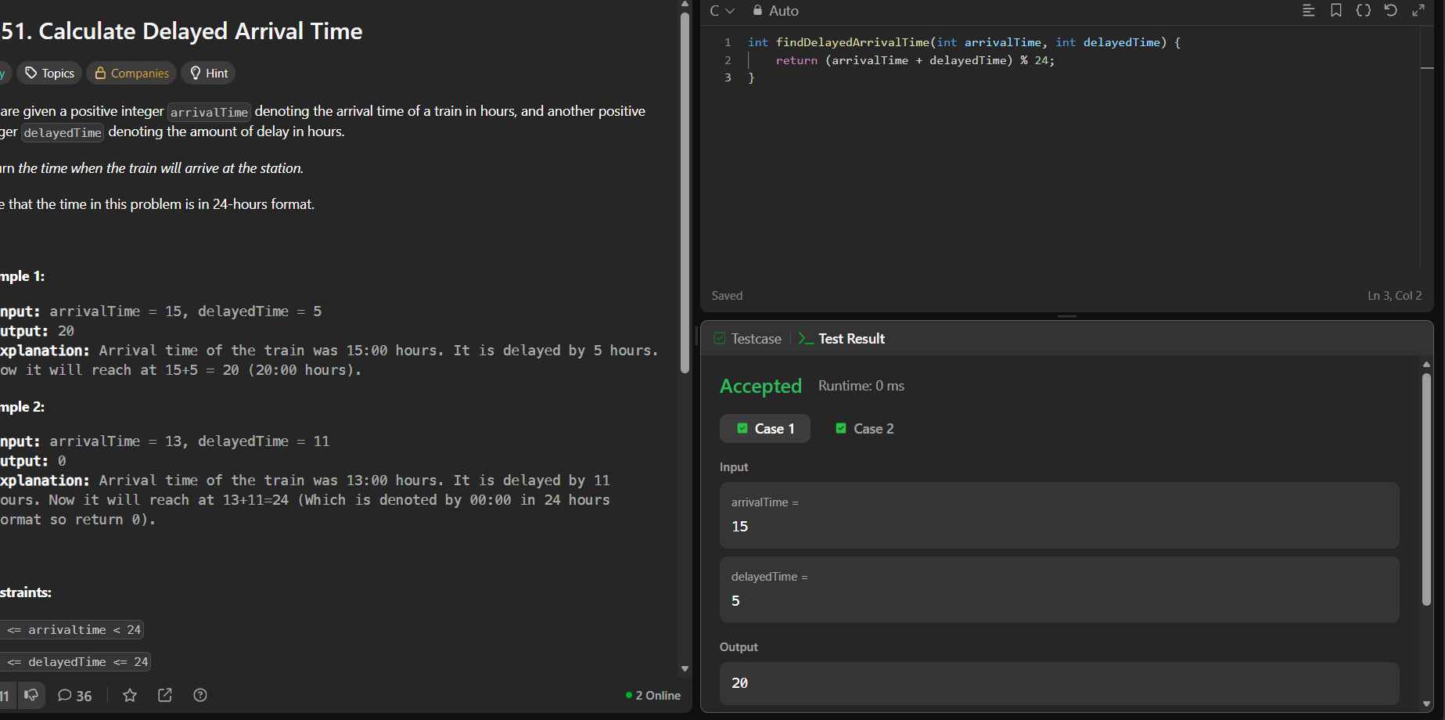
url: https://leetcode.com/problems/calculate-delayed-arrival-time/

(QUES 5): CODE:
int distanceTraveled(int mainTank, int additionalTank) {
int distance = 0;
while (mainTank >= 5) {
distance += 50;
mainTank -= 5;

if (additionalTank >= 1) {
mainTank += 1;
additionalTank--;
}
}
distance += mainTank * 10;
return distance;
}
SCREENSHOT: 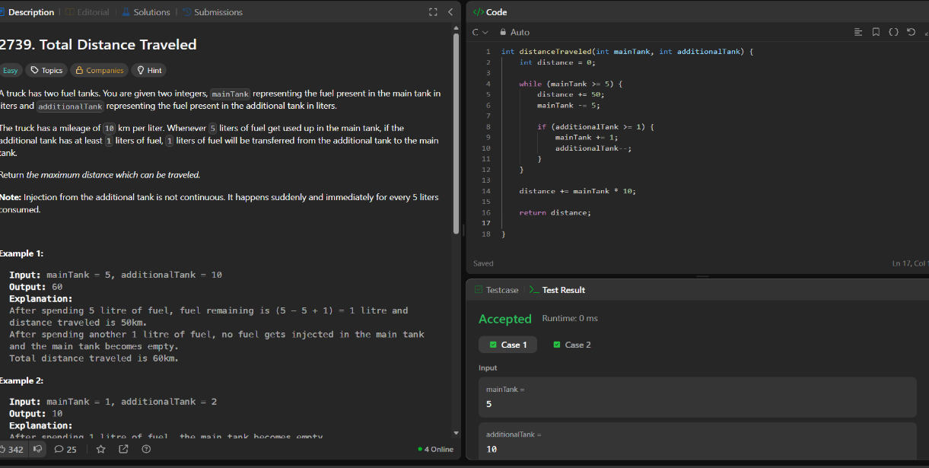
URL: https://leetcode.com/problems/total-distance-traveled/

